Day 5 Report: FastAPI Pydantic Validation and CRUD Operations

Objective
To learn request validation using Pydantic in FastAPI and implement CRUD APIs for a Student Management System.

Tools and Technologies Used
Python, FastAPI, Pydantic, Uvicorn, Swagger UI

Tasks Completed
Created Student Model, Email Validation, Age Validation, GET, POST, PUT and DELETE APIs.

Screenshots and Results
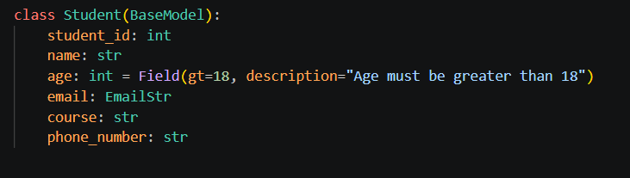
Figure 1: Student Pydantic Model with Validation
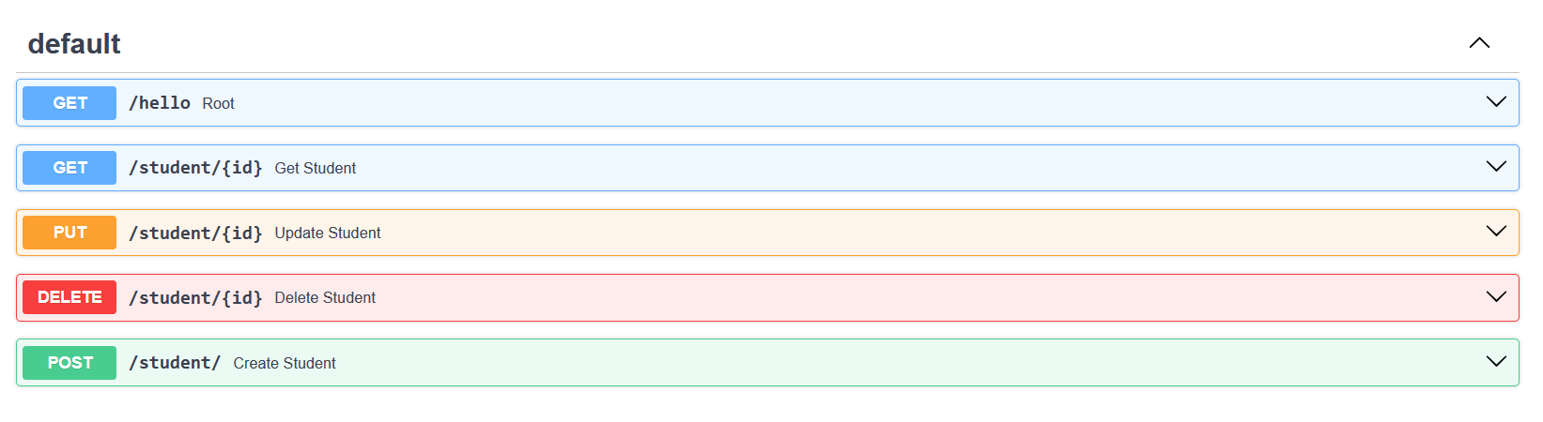
Figure 2: Swagger UI Showing All Endpoints
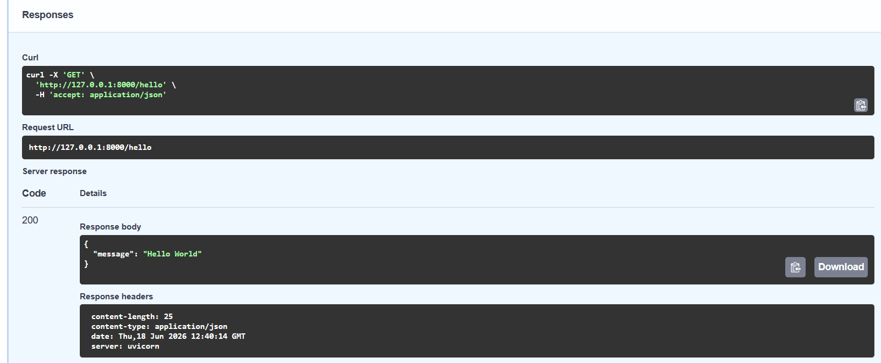
Figure 3: GET /hello API Response
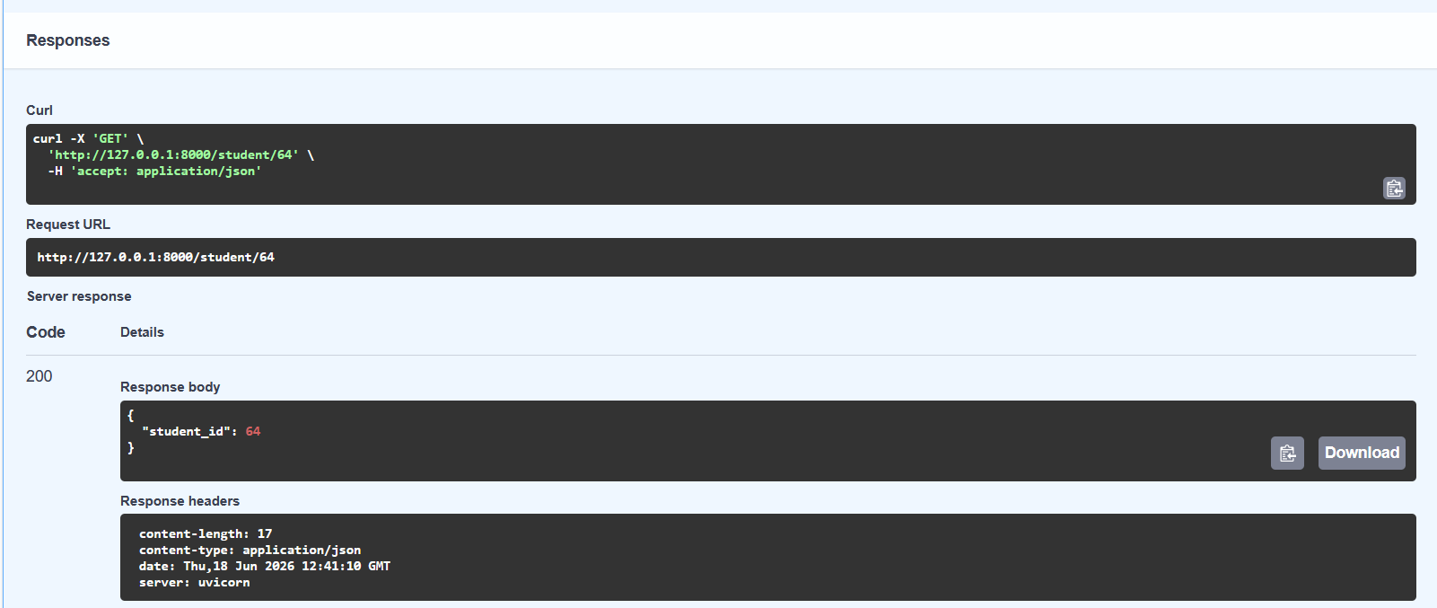
Figure 4: GET /student/{id} API Response
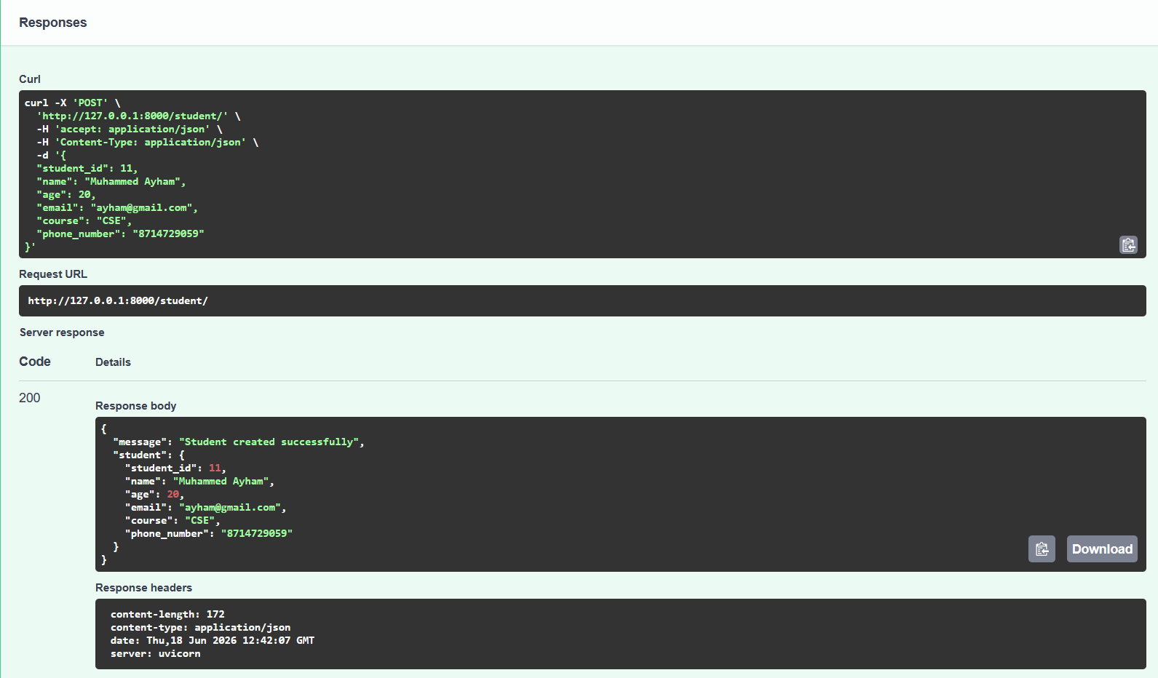
Figure 5: POST /student API Response
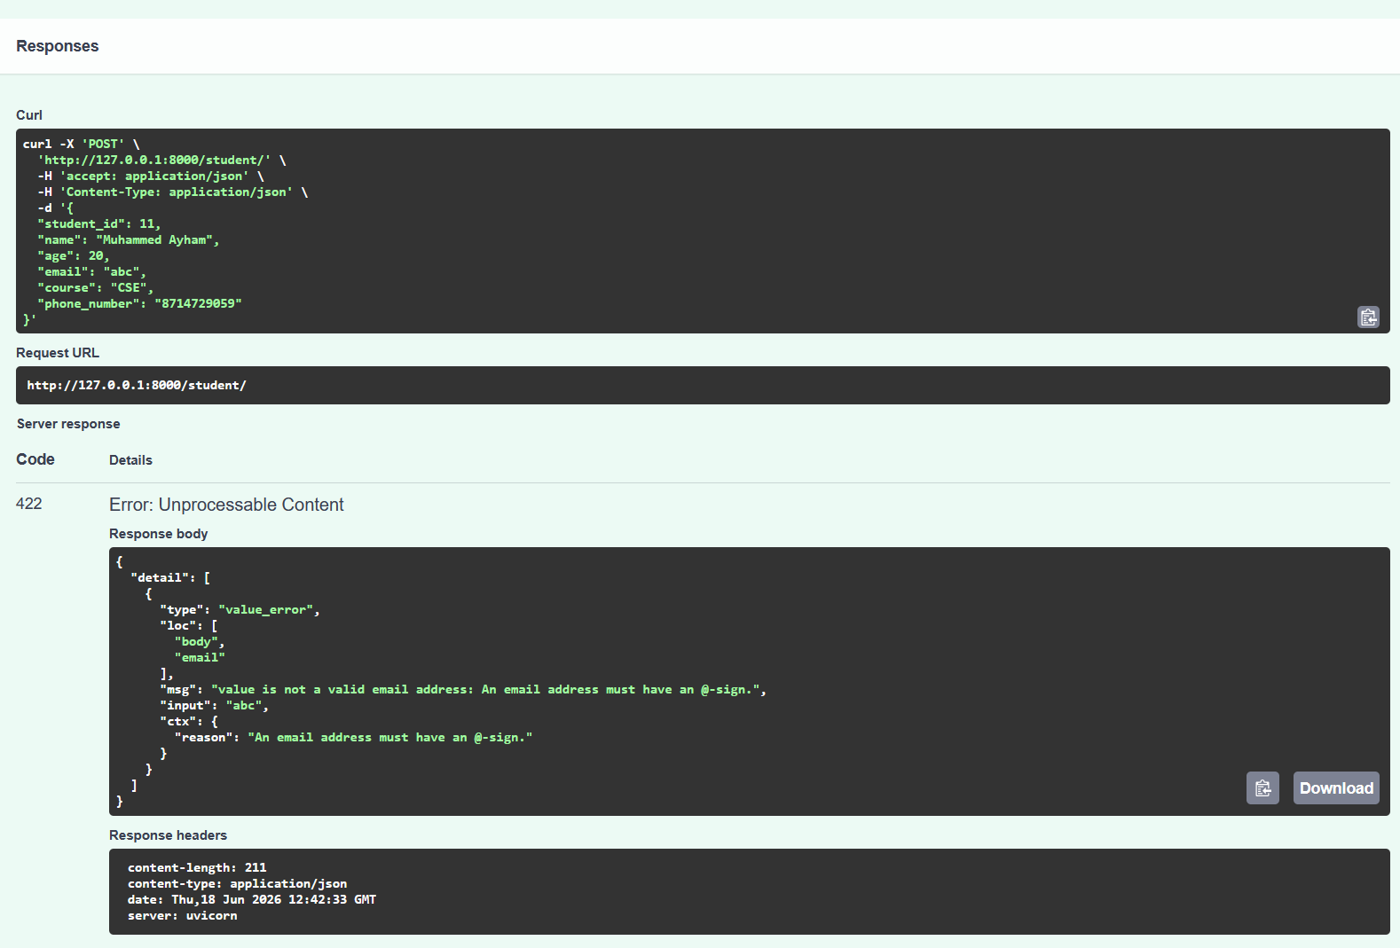
Figure 6: Email Validation Error
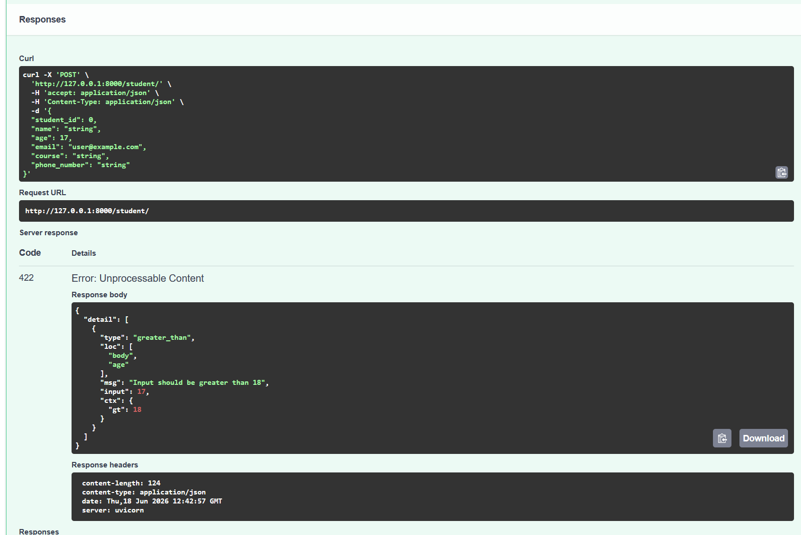
Figure 7: Age Validation Error
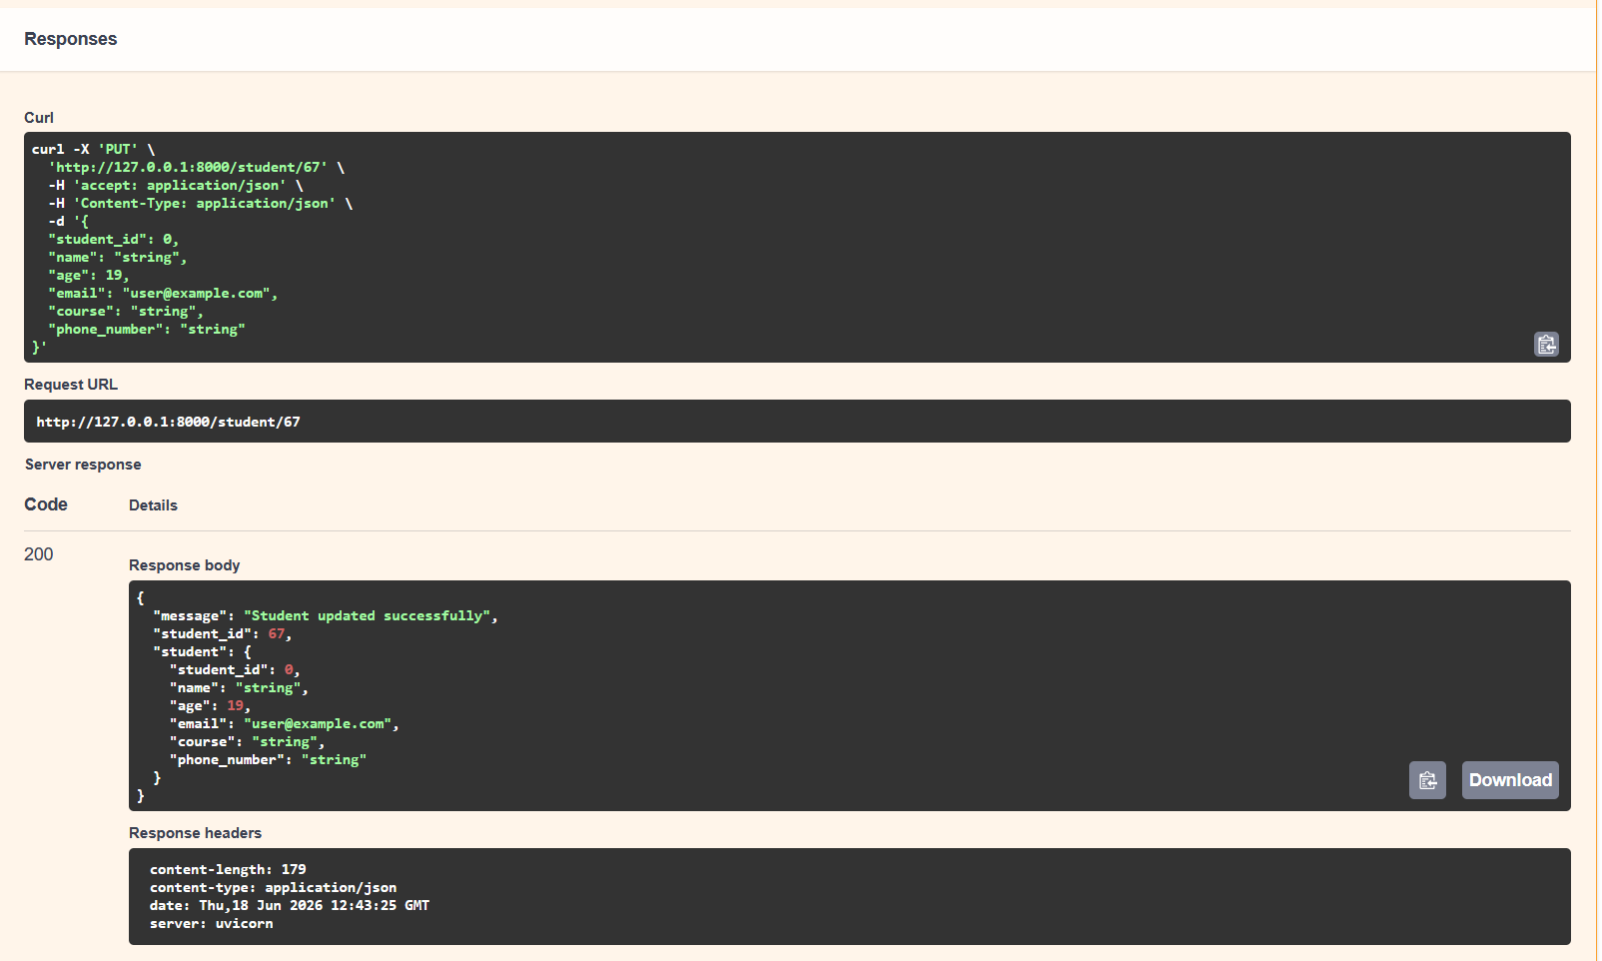
Figure 8: PUT /student/{id} API Response
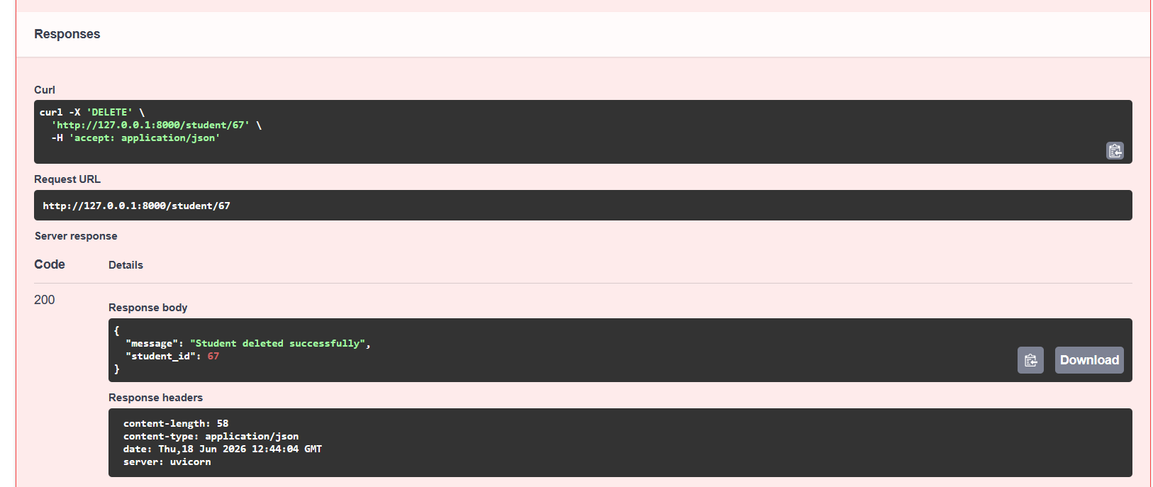
Figure 9: DELETE /student/{id} API Response

